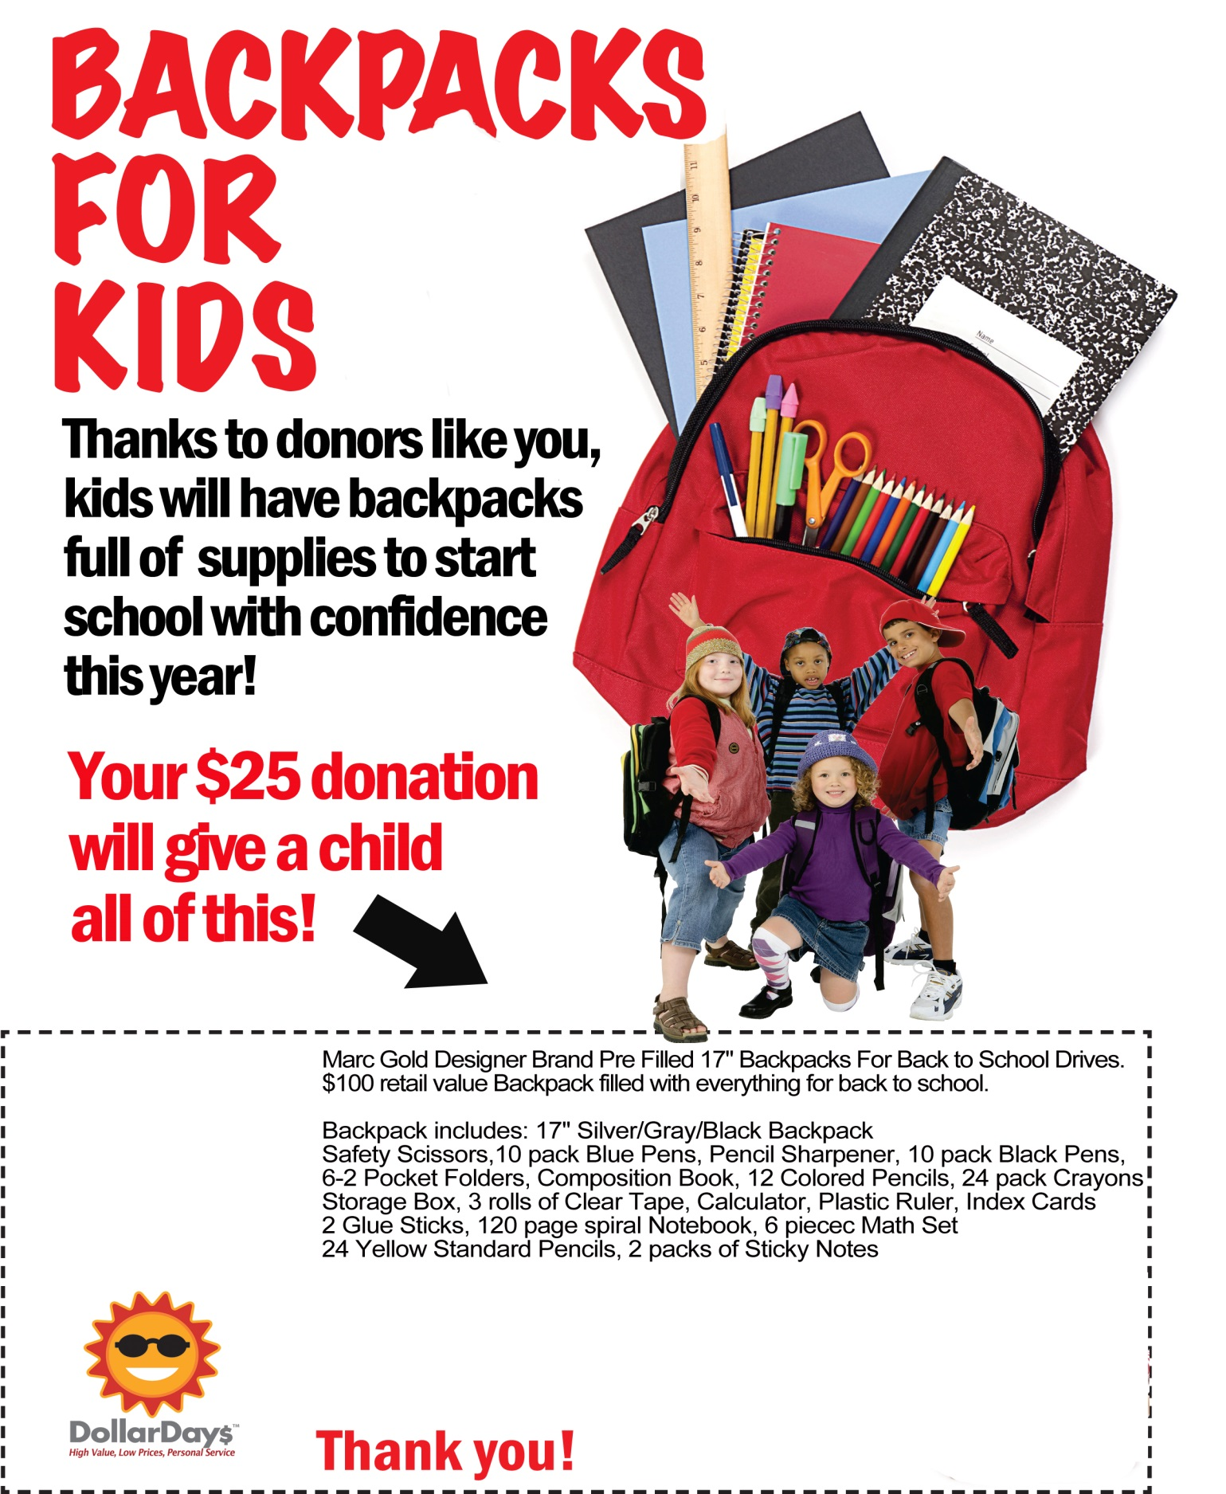

**Your**

**Logo**

**Here**

**Visit our WishList to donate a backpack:  
www.dollardays.com/xxxxxxxxxxxxx/wishlist.html**